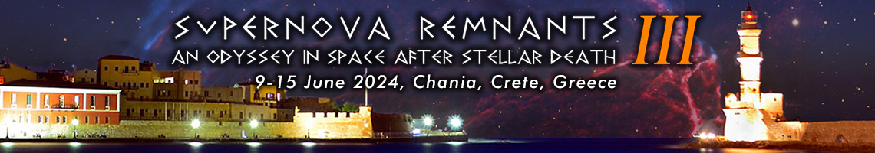

**Excursion 2: Full day tour to Anoskeli winery & olive mill and to Paleochora, the "Libyan Bride”**

**Order Form**

**Deadline: Wednesday, April 10, 2024 09:00 GMT**

Date: _________________

Conference Registered Name: ______________________________

Institution: _____________________________________________

E-mail: ________________________________________________

Full-day excursion to Anoskeli winery & olive mill and to Paleochora, the "Libyan Bride" on Saturday, June 15, 2024 –

Participant Name(s):

_______________________________________________________

_______________________________________________________

_______________________________________________________

_______________________________________________________

_______________________________________________________

|  |  |
| --- | --- |
| **Unit Cost** | **Quantity** |
| 50 EUR |  |
| **GRAND TOTAL** |  |

By signing this form, I commit to paying ________ EUR in cash upon registration at the meeting.

Signature: